**Practical 1**

**Aim : Introduction to Arduino**

1. **Introduction to Arduino circuits and breadboarding**

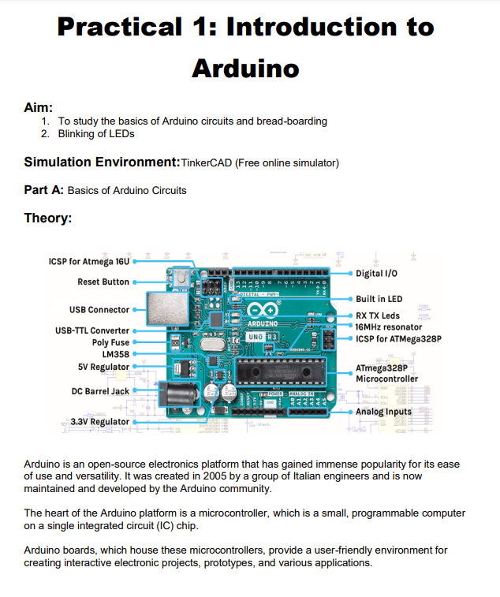

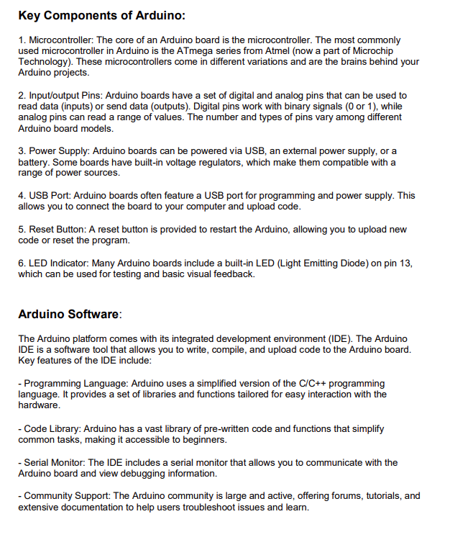

1. **Blinking of LEDs**

**Component :**

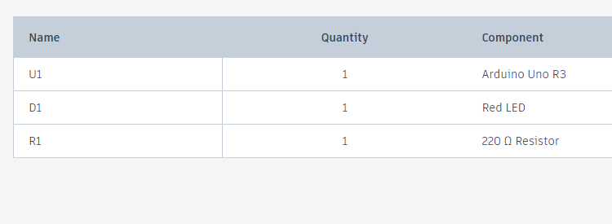

**Code:**

int ledPin = 8;

void setup()

{

pinMode(ledPin, OUTPUT);

}

void loop()

{

digitalWrite(ledPin, HIGH); // On

delay(1000); // 1000 secs delay

digitalWrite(ledPin, LOW); // Off

delay(1000); // 1000 secs delay

}

**Output:**

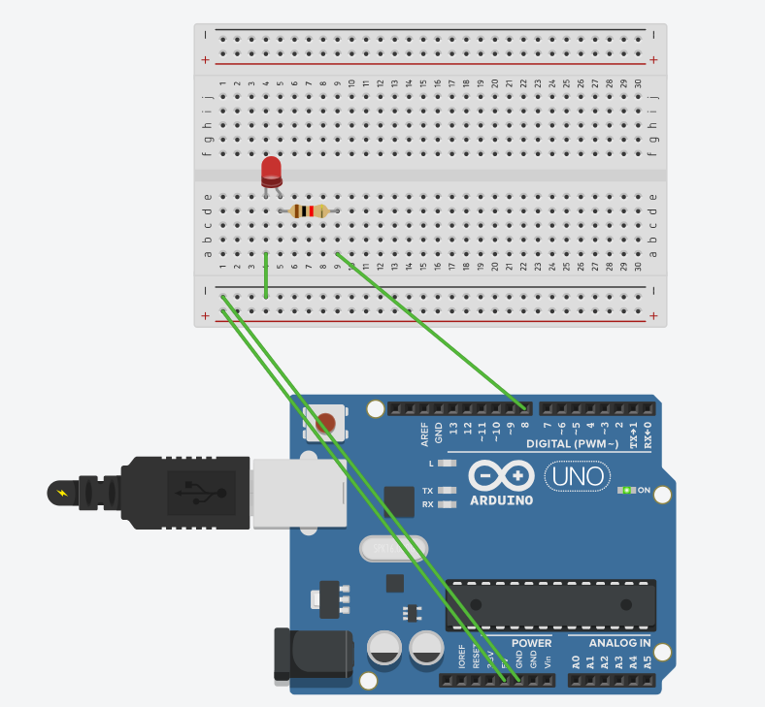

**Practical 2**

**Aim : Program using Light Sensitive Sensors**

**Component:**

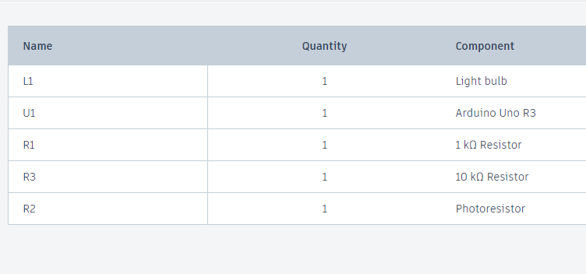

**Code:**

int bulb = 7;

int ldr = A3;

void setup()

{

pinMode(bulb, OUTPUT);

pinMode(ldr, INPUT);

}

void loop()

{

if(analogRead(ldr) > 500)

digitalWrite(bulb,0);

else

digitalWrite(bulb,1);

}

**Output:**

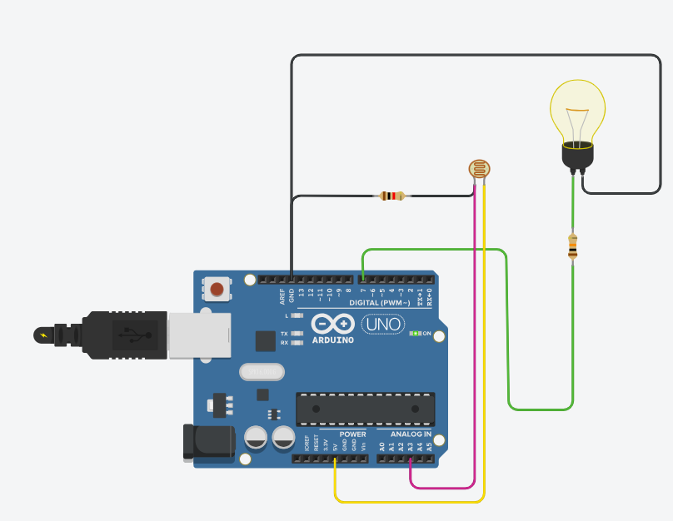

**Practical 3**

**Aim : Program using temperature sensors**

**Component:**

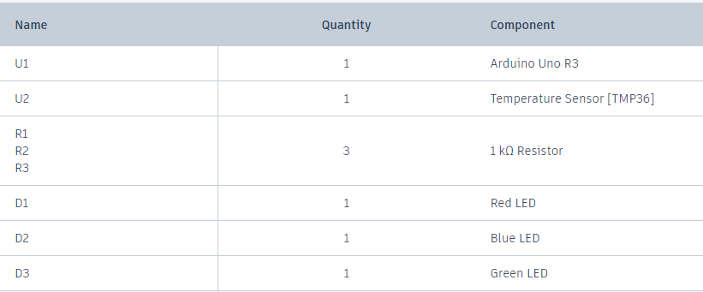

**Code:**

int baselineTemp = 0;

int celsius = 0;

int fahrenheit = 0;

void setup()

{

pinMode(A0, INPUT);

Serial.begin(5000);

pinMode(2, OUTPUT);

pinMode(3, OUTPUT);

pinMode(4, OUTPUT);

}

void loop()

{

baselineTemp = 40;

celsius = map(((analogRead(A0) - 20) * 3.04), 0, 1023, -40, 125);

fahrenheit = ((celsius * 9) / 5 + 32);

Serial.print(celsius);

Serial.print("C");

Serial.print(fahrenheit);

Serial.print("F");

if (celsius < baselineTemp)

{

digitalWrite(2, LOW);

digitalWrite(3, LOW);

digitalWrite(4, LOW);

}

if (celsius >= baselineTemp && celsius < baselineTemp+10)

{

digitalWrite(2, HIGH);

digitalWrite(3, LOW);

digitalWrite(4, LOW);

}

if (celsius >= baselineTemp + 10 && celsius < baselineTemp+20)

{

digitalWrite(2, HIGH);

digitalWrite(3, HIGH);

digitalWrite(4, LOW);

}

if (celsius >= baselineTemp + 20 && celsius < baselineTemp+30)

{

digitalWrite(2, HIGH);

digitalWrite(3, HIGH);

digitalWrite(4, HIGH);

}

if (celsius >= baselineTemp + 30)

{

digitalWrite(2, HIGH);

digitalWrite(3, HIGH);

digitalWrite(4, HIGH);

}

delay(1000);

}

**Output:**

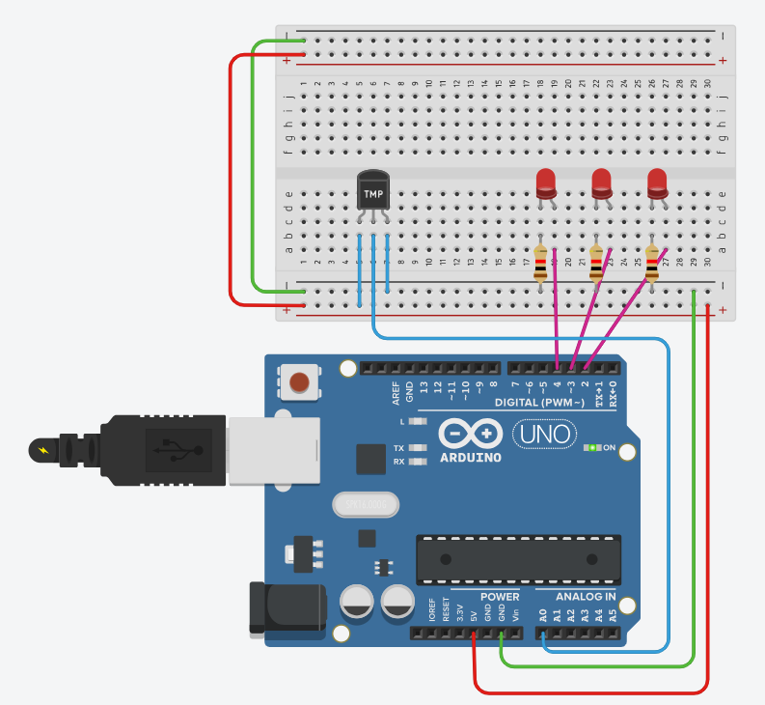

**Practical 6**

**Aim :Programs using Ultrasonic Sensors**

**Component:**

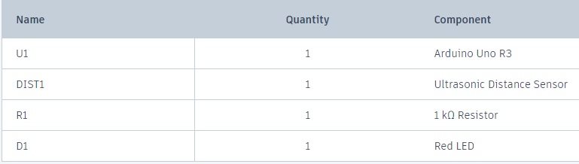

**Code:**

int trigger = 12;

int echo = 13;

int led = 8;

long duration = 0;

int cm = 0;

int inch = 0;

void setup() {

// put your setup code here, to run once:

Serial.begin(9600);

pinMode(trigger, OUTPUT);

pinMode(echo, INPUT);

pinMode(led, OUTPUT);

}

void loop() {

// put your main code here, to run repeatedly:

digitalWrite(trigger, LOW);

digitalWrite(trigger, HIGH);

digitalWrite(trigger, LOW);

duration = pulseIn(echo, HIGH);

cm = duration*0.034/2;

inch = duration*0.0133/2;

if (inch < 50){

digitalWrite(led, HIGH);

} else {

digitalWrite(led, LOW);

}

if (inch < 100 ) {

Serial.print("Inches: ");

Serial.println(inch);

Serial.print("Cm: ");

Serial.println(cm);

}

delay(5000);

}

**Output:**

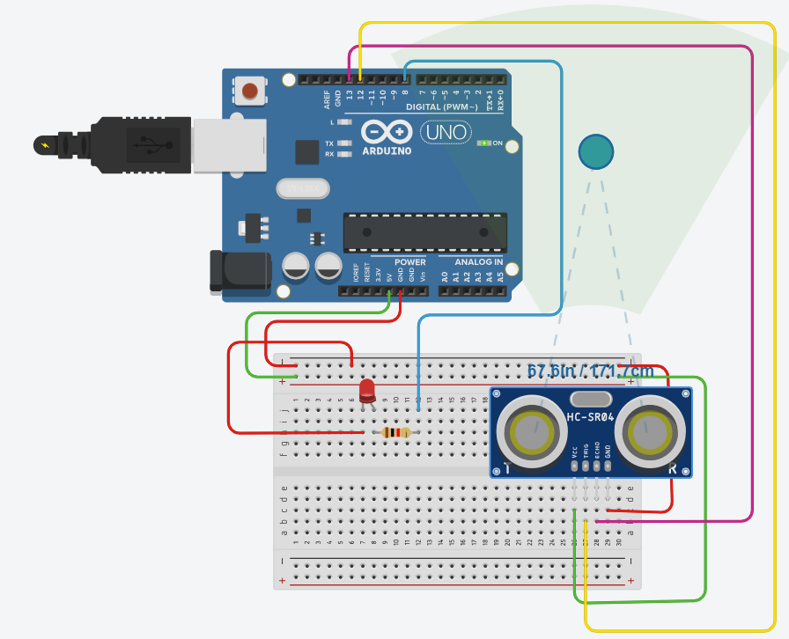

**Practical 4**

**Aim : Program using Humidity Sensors.**

**Component:**

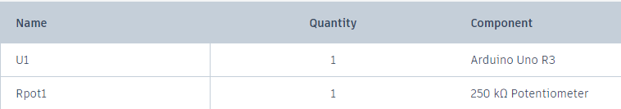

**Code:**

// C++ code

//

const int analogIn=A1;

int humiditySensorOutput=0;

void setup()

{

Serial.begin(9600);

}

void loop()

{

humiditySensorOutput=analogRead(analogIn);

int humidityPercentage = map(humiditySensorOutput, 0, 1023, 10, 70);

Serial.print("\nhumidity:");

Serial.print(humiditySensorOutput);

Serial.print("%");

delay(5000);

}

**Output :**

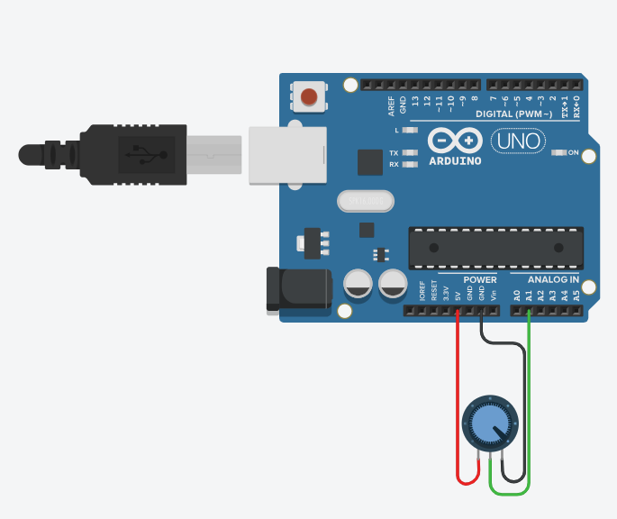

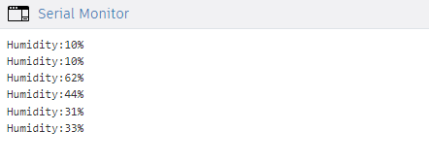

**Practical 9**

**Aim: Program using Servo motors**

**Component:**

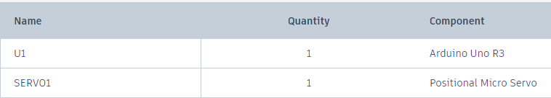

**Code:**

// C++ code

//

#include<Servo.h>

Servo servoBase;

void setup()

{

servoBase.attach(A1);

servoBase.write(0);

}

void loop()

{

for(int i=0; i<=180; i+=10)

{

servoBase.write(i);

delay(2000); // Wait for 1000 millisecond(s)

}

}

**Output :**

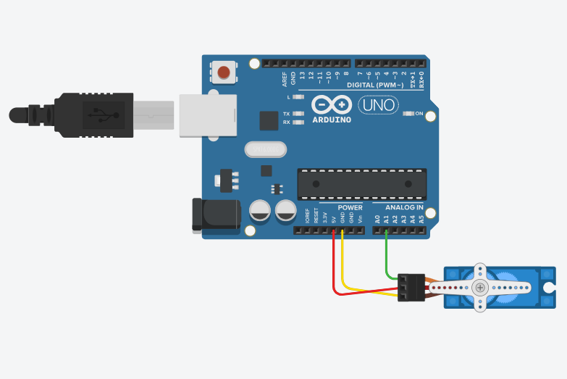

**Practical 7**

**Aim : Programs using digital infrared motion sensors**

**Component:**

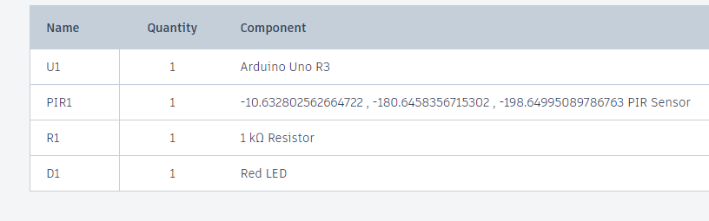

**Code:**

int sensorState= 0;

void setup()

{

pinMode(2, INPUT);

pinMode(LED_BUILTIN,OUTPUT);

}

void loop()

{

sensorState = digitalRead(2);

if(sensorState==HIGH)

{

digitalWrite(LED_BUILTIN,HIGH);

}

else

{

digitalWrite(LED_BUILTIN,LOW);

}

delay(10);

}

**Output :**

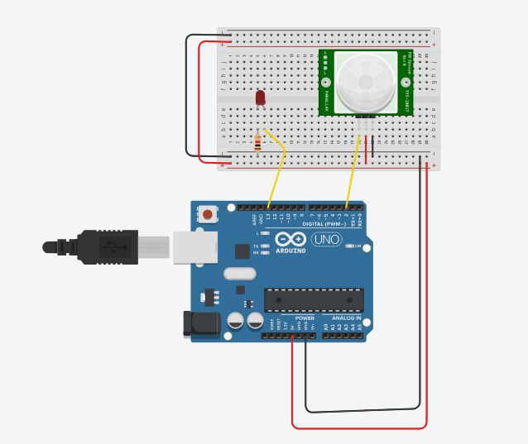

**Practical 8**

**Aim :** . **Programs using gas sensors**

**Component:**

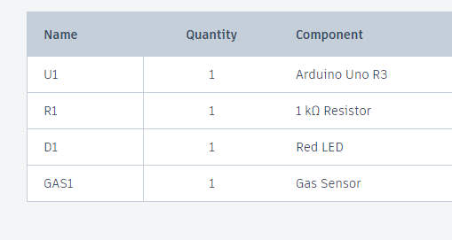

**Code:**

int LED =A1;

const int gas =0;

int MQ2pin = A0;

void setup()

{

Serial.begin(9600);

}

void loop()

{

float sensorValue,MQ2pin;

sensorValue =analogRead(MQ2pin);

if(sensorValue<=170){

digitalWrite(LED,LOW);

Serial.print(sensorValue);

Serial.println("SENSOR VALUE”);

}

else

{

digitalWrite(LED,HIGH);

Serial.println("SMOKE DETECTED);

Serial.println(sensorValue);

}

delay(1000);

}

float getsensorValue(int pin)

{

return(analogRead(pin));

}

**Output :**

